Phonak

Insight

Phonak Audéo Life™ sets a new standard for reducing clients’ anxiety around water and   
physical activities

For decades, water has been one of the biggest enemies of hearing aids. Research shows people with hearing loss experience anxiety wearing hearing aids around water. With Audéo™ Life, the world’s first waterproof* rechargeable hearing aid enters the market, with additional protection against moisture, sweat and other challenging real-world conditions.

**Chase Smith, AuD / April 2022**

# Key takeaways

* Audéo Life is waterproof* and sweatproof, and has additional protection beyond a standard water resistant hearing aid.
* Audéo Life features additional internal seals and protective coatings, inductive charging, and a pin-less receiver port.
* Audéo Life was tested using freshwater, seawater, and pool water to mimic real-world situations like swimming and sweating.

# Considerations for practice

* Audéo Life could considerably reduce your client’s anxiety around water and during physical activities.
* Talk to your clients about their fears and anxieties of using hearing aids around water, and how Audéo Life can address them.
* Audéo Life is ideal for lead generation, targeting active clients with no hearing aid experience as well as experienced wearers who need a more robust option.

# Why are waterproof hearing aids so important?

Hearing aids, like most electronic devices, are sensitive to moisture. Water, sweat, and other liquids can cause corrosion and damage internal circuitry and other components. While this can be a major concern for active people, this can also impact people who are prone to sweating, those who spend a lot of time around water, or people who live in warm and humid locations.

In a recent survey of people with hearing loss in the United States, Germany, and Australia, many participants reported they would feel anxious wearing hearing aids during water-based activities like going to the beach, working out, or swimming. When presented with the option of a robust hearing aid that was waterproof and sweatproof, a significant reduction in anxiety was reported. In fact, such a solution would motivate 40% of participants to upgrade their hearing aids sooner and would motivate 20% of people who had not purchased hearing aids to reconsider their decision.1

# How are hearing aids tested for waterproofing?

Many hearing aids, including those from Phonak, are specifically marketed as being “water resistant.” While there is no industry standard for what water resistant and waterproof actually mean in terms of real world performance, hearing aids are assigned an Ingress Protection code or IP rating to demonstrate the level of protectionhearing aids have against moisture and debris intrusion. IP ratings are comprised of a two digit number and are defined by the International Electrotechnical Commission (IEC).

The first digit indicates protection against dust and debris intrusion, and can range in value from 0 (no protection) to 6 (full protection from dust). The second digit indicates protection from water intrusion and can range from 0 (no protection) to 9 (can withstand direct spray of high-pressure, high-temperature industrial water jets from multiple angles). Most hearing aids sold today carry an IP68 rating, indicating full protection from dust and debris as well as survival in a given depth of water for a specified number of minutes as defined by the manufacturer. For Phonak hearing aids, that is one meter (3.28 feet) of freshwater for 60 minutes with the hearing aid still functional once removed from the water.

Unfortunately, because of variations in testing protocols between manufacturers it can be challenging to understand how these tests translate into real-world performance.   
  
Additionally, because these tests are performed only using clean, freshwater, they do not necessarily represent the sources of moisture a hearing aid wearer interacts with on a daily basis like sweat or pools. The addition of salt, chlorine, and other chemicals alter the chemical properties of water, making it more damaging to the metal and electrical components of the hearing aid. Taking this into consideration, most hearing aids with a rating of IP68 are referred to as “water resistant” and care should be taken not to submerge them in water.

**What makes Audéo Life different?**

Audéo Life was specifically designed to combine the proven hearing performance and crisp natural sound2 of Audéo Paradise with a housing that is built to withstand the harsh environments that hearing aid wearers may find themselves in on a regular basis. This includes humidity, sweat from heat and physical activity, and sea and pool water. But how is this different from a normal hearing aid?

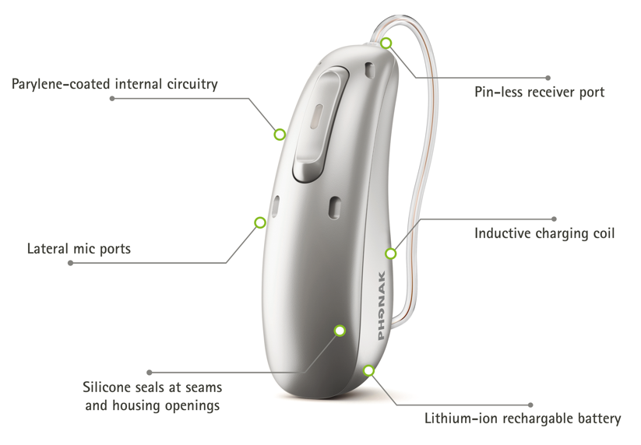

Audéo Life has several key features that provide enhanced protection from moisture intrusion. These include:

* Additional protection over the rear microphone to protect from direct water pressure.
* Inductive charging that eliminates the need for titanium posts in the hearing aid, reducing the number of openings in the housing.
* Coating of the internal module and rechargeable battery with a thin layer of parylene (a flexible plastic polymer often used to protect sensitive electronic equipment from damage due to moisture and corrosion in inhospitable environments).
* Silicone seals added behind the receiver port, locking pins and housing seams.
* A pin-less receiver port that not only further reduces the number of open points in the housing, but also no longer requires a tool to change the receiver.

While Audéo Life hearing aids are built to withstand water, how protected are Phonak receivers? SDS 4.0 receivers are encapsulated in a plastic polymer to resist water intrusion. However, water can still enter the receiver through the receiver spout at the end of the receiver body. Wearers of Audéo Life should avoid fully submerging their heads in the water while wearing the hearing aids as this can cause water to enter the receiver. While domes and CeruShield™ disks are designed to help protect the receivers from cerumen, it does not offer the same level of protection from water.

# How do we know Audéo Life goes beyond IP68?

​Designing a robust hearing aid was only the start. A battery of additional tests beyond IP68 was designed to prove that Audéo Life could withstand harsher conditions. Depth tests in seawater and pool water, were conducted using Audéo Life hearing aids.

**Immersion testing**  
For the immersion tests, Audéo Life hearing aids were placed in two climate-controlled chambers, one filled with seawater to simulate diving into the ocean and another filled with chlorinated water to simulate being submerged in a pool. Both test chambers were pressurized to 50 mbar to simulate a depth of 50 centimeters of water and heated to a temperature of 50°C/122°F to accelerate the conventional aging process of the hearing aids and simulate their 5 year intended lifespan.3

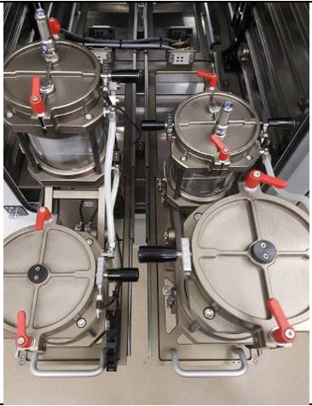 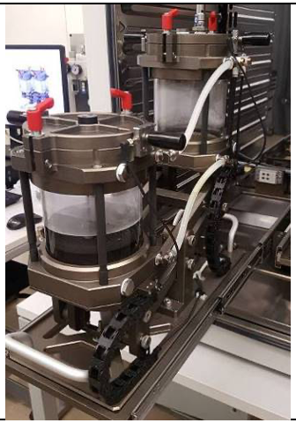

**Figure 1: Test setup of the seawater and pool water dive test in climate-controlled chambers.**

The hearing aids then remained submerged in the water for five minutes. The pressure was then released and the water drained from the chamber. Once the water had cleared the chamber, the chamber was resealed and the hearing aids remained in the high-humidity environment for an additional ten minutes. This test was completed 520 times on each hearing aid in both seawater and poolwater conditions.

Additional acoustical measurements with all hearing aids as well as a radio frequency (RF) link performance tests were conducted. They were performed on the hearing aids before and after the depth tests using the Maximum Power Output (MPO) and Full On Gain (FOG) with a 50dB SPL input signal. The Reference Test Setting (RTS) frequency response was measured with a 60dB SPL input signal.

The results showed that for seawater, seven out of ten hearing aids were still functioning within normal limits after the 520 test cycles. Of the three that did not pass, one hearing aid failed after 147 cycles, one failed after 288 cycles, and the third also failed after 288 cycles. However, the third hearing aid did recover after being allowed to dry and later tested within normal limits. For pool water, nine out of ten hearing aids passed the final test, with one failing after 520 cycles.

# The world’s first waterproof* rechargeable hearing aid

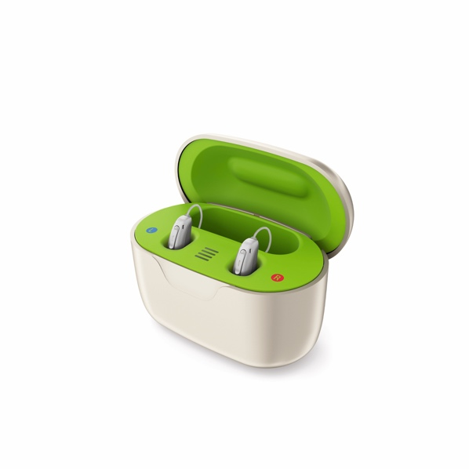Research shows that wearing hearing aids during water-based activities is a source of anxiety for people with hearing loss.1 This anxiety has also kept some people with hearing loss from purchasing hearing aids.1 Audéo Life sets a new standard in moisture and dust protection in rechargeable hearing aids and therefore could considerably reduce your clients’ anxiety around water and physical activities.1 Audéo Life enables hearing aid wearers to confidently participate in the water-based activities they love most and face challenging everyday activities with confidence. In addition, the improvements made to waterproof the Audéo Life housing would motivate 1 in 5 people with untreated hearing loss to purchase their first pair of hearing aids because of their performance in demanding real-world conditions.1

**Conclusion**

Audéo Life takes consumer confidence to the next level with the first rechargeable hearing aid that is waterproof* and sweatproof. Wearers can now feel confident their hearing aids are protected should they drop them in water. With the proven hearing performance and advanced features of the Paradise platform, wearers can enjoy the best of Phonak technology with the peace of mind provided by enhanced protection from water.

**About the author**

# Chase Smith, AuD

Chase joined Sonova in 2016 and is currently Sales Audiology Manager at Phonak HQ in Switzerland. Chase received his Doctor of Audiology degree from Northwestern University. He has previously worked as a Regional Sales Manager for Phonak US and has interned at Advanced Bionics, Connect Hearing, and Phonak.

# References

1. Taphuntsang, D.(2020). Market research ID 4398.  Please contact marketinsight@phonak.com if you are interested in further information
2. Taphuntsang, D. (2020). Market research ID 4387. Please contact marketinsight@phonak.com if you are interested in further information.
3. Phonak internal testing protocols.

*Up to 50 cm



028-2361-02/V1.00/2022-04/ © 2022 Sonova AG All rights reserved