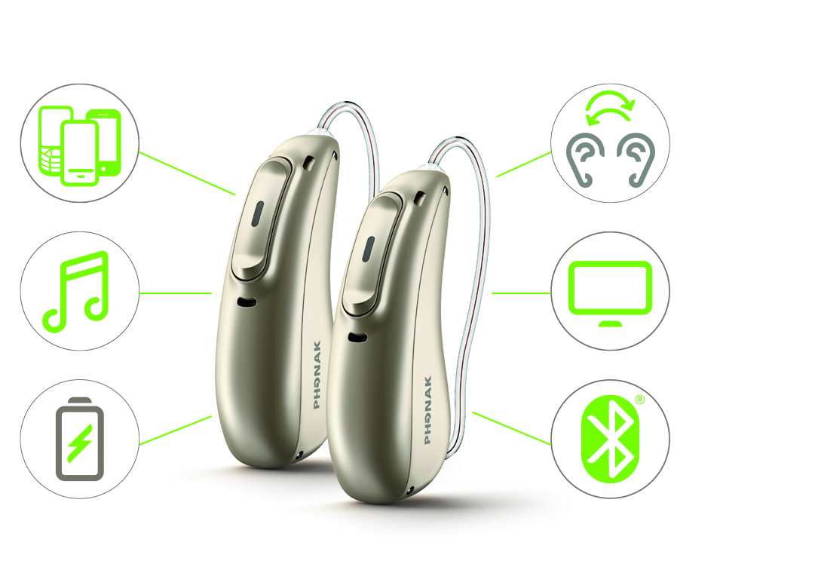MarketingMac:Archive from NAS:Archive - Marketing:02_Launches:17 - 2017 - Season 3 August:03. Marketing Communication:01. Co-op:PH_Secondarylogo_TRUSTED_PROVIDER.eps

**Join us for our  
MODERN MARVEL HEARING EVENT**

**2 DAYS ONLY, December XX–XX, 2018!**

Reserve your spot and receive:

• **FREE** Hearing Screening

• **Risk-free** 30 day in-home trial

• **Free demonstration** of   
Audéo Marvel technology

1 Jansen, S. & Woodward, J. (2018). Love at first sound: The new Phonak precalculation. Phonak Insight, retrieved from  www.phonakpro.com/evidence, accessed October 17, 2018.

2 Field Study News about Phonak StereoZoom in preparation, available by end of 2018 at www.phonakpro.com/evidence

3 Winneke, A., Latzel, M. & Appleton-Huber (2018). Less listening and memory effort in noisy situations with StereoZoom, Phonak Field Study News, retrieved from www.phonakpro.com/evidence,   
 accessed October 17, 2018.

4 Legarth, S., Latzel, M. & Rodrigues, T. (2018). Media streaming: The sound quality wearers prefer, Phonak Field Study News, retrieved from www.phonakpro.com/evidence, accessed October 17, 2018.

© 2018 Sonova USA Inc. All rights reserved. MS-XXXXXX. 209DB

Dear [NAME],

You’ve previously been interested in finding out more about improving your hearing through a variety of solutions. We at [PRACTICE NAME] would like to offer you the opportunity to test drive the most advanced hearing device we’ve come across, at no charge.

We understand that those who suffer from hearing loss need one defining function from a hearing device: clear, rich sound. Hearing well in various situations is important, such as restaurants, family time and driving in your car. You need hearing aids that can keep up with your lifestyle.

Introducing **Phonak Audéo™ Marvel**, a first-class hearing device that gives you crisp hearing and so much more. These multifunctional hearing aids deliver excellent sound quality, are easy to use and packed with convenient hands-free features to make hearing and your life easier.

**What makes Audéo Marvel hearing aids so marvelous?**

* **Exceptional sound quality from the first fit1**
* **Better speech understanding in noise2**
* **Reduced listening effort3**
* **Top-rated streamed sound quality from your multimedia devices4**

Combine that with a powerful rechargeable battery and TV/smartphone connectivity — **all in one device**. With all these added features, it’s so much more than a hearing aid; it’s a **multifunctional marvel**.

For a limited time, you’re invited to come back to our office and try out Phonak Audéo Marvel, risk-free, and experience **love at first sound**.   
Give us a call and reserve your spot to test out this revolutionary hearing technology today.

Sincerely,

Signature

[PROVIDER NAME]

[PROVIDER CREDENTIALS]

**Introducing a multifunctional marvel.**

Practice Logo

[Practice Name]  
[Street Address]  
[City, State]  
[Phone]  
[Website]