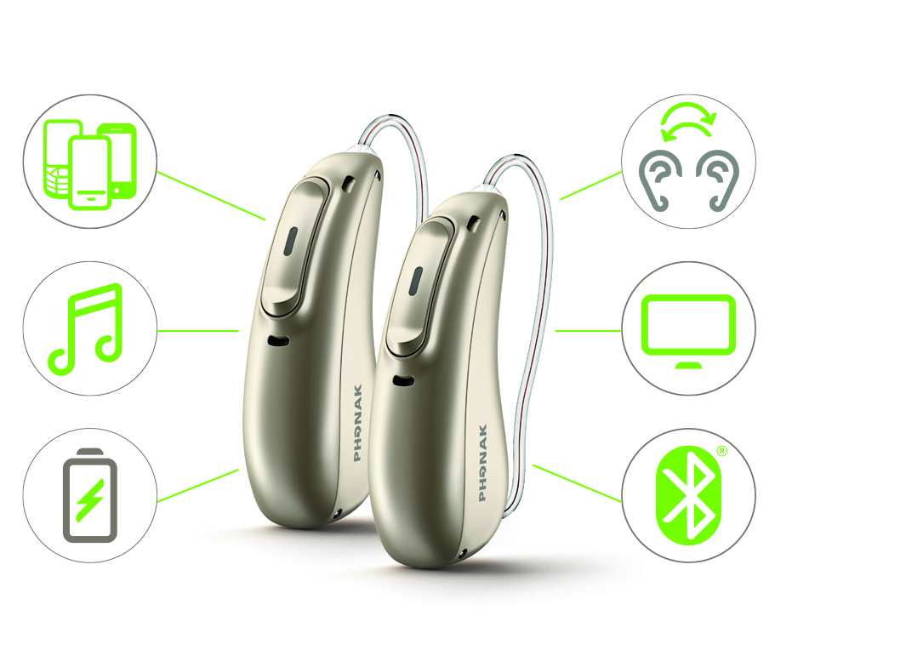MarketingMac:Archive from NAS:Archive - Marketing:02_Launches:17 - 2017 - Season 3 August:03. Marketing Communication:01. Co-op:PH_Secondarylogo_TRUSTED_PROVIDER.eps

© 2018 Sonova USA Inc. All rights reserved. MS-XXXXXX. 213DB

**Join us for our  
MODERN MARVEL HEARING EVENT**

**2 DAYS ONLY, December XX–XX, 2018!**

Reserve your spot and receive:

• **FREE** Hearing Screening

• **Risk-free** 30 day in-home trial

• **Free demonstration** of   
Audéo Marvel technology

Dear [NAME],

You’ve previously been interested in finding out more about improving your hearing through a variety of solutions. We at [PRACTICE NAME] would like to offer you the opportunity to test drive the most advanced hearing device we’ve come across.

We understand that those who suffer from hearing loss need one defining function from a hearing device: clear, rich sound. But with today’s new technologies, there are functions that can make your day-to-day life easier, such as rechargeable batteries, hearing apps on your phone, and connecting to your household devices. You need hearing aids that can keep up with today’s technology landscape.

Introducing **Phonak Audéo™ Marvel**, a first-class hearing device that gives you crisp hearing and so much more.

**Through years of research and development, Phonak Audéo Marvel   
has been built to provide you with:**

* **Clearer, richer sound** than ever before, with updated directional microphones and AutoSense OS™ 3.0
* **Connectivity** to any Bluetooth®-enabled device, including iOS and Android phones
* **AirStream technology**, allowing you to stream directly from any TV and stereo system. Use your hearing aids like headphones to enjoy your favorite TV programs, music and movies
* **Rechargeable** batteries, removing the hassle of changing batteries
* **myPhonak app** allows you to keep track of your hearing experience and gives you the confidence and peace of mind that your personal hearing needs are addressed

Combine these features with a long-lasting battery and TV/smartphone connectivity — **all in one device**. With all these added features, it’s so much more than a great hearing aid; it’s a **multifunctional marvel**.

For a limited time, you’re invited to come back to our office and try out Phonak Audéo Marvel, risk-free, and experience **love at first sound**.   
Give us a call and reserve your spot to hear this revolutionary hearing technology today.

Sincerely,

Signature

[PROVIDER NAME]

[PROVIDER CREDENTIALS]

**Introducing a multifunctional marvel.**

Practice Logo

[Practice Name]  
[Street Address]  
[City, State]  
[Phone]  
[Website]