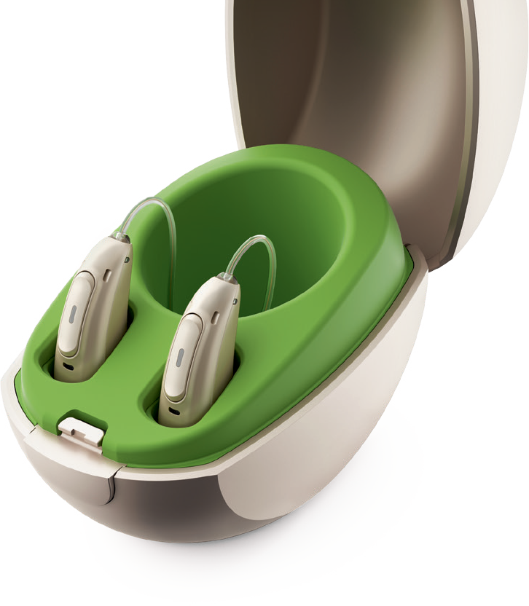
Practice Name

[PRACTICE LOGO]
Street
City, State Zip

Dear [PATIENT NAME],

I hope you’re enjoying the excellent sound quality and connectivity functions of your Phonak Audéo™ Marvel hearing aids. The good news is that now you can enjoy even more superb benefits with a quick, easy and free technology update — so schedule an appointment today.

What do you get with your technology update?

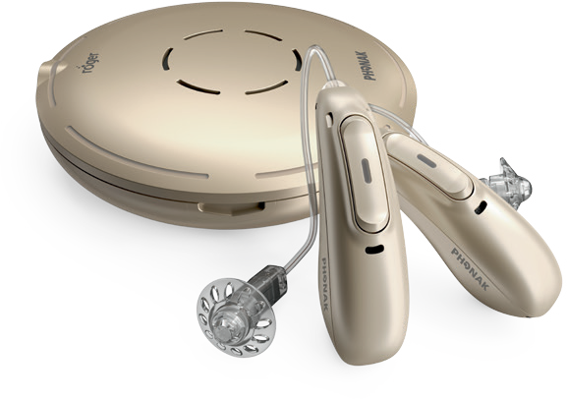
Easy access to even more hearing performance
- Hearing aid users understand almost 10 times better with Roger™ technology in noise and over distance than people with normal hearing.1
- Phonak Audéo Marvel now features RogerDirect™, which allows Roger technology
to stream directly to your hearing aids without having to attach an external receiver.
- Roger technology combined with Marvel hearing performance and exceptional sound quality is an unbeatable combination.

A more personalized hearing experience
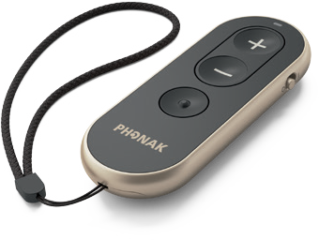
To help you get the most out of your hearing aids, the update will also give you access to new functions within the myPhonak app. The new advanced Remote Control function allows you to personalize and control your hearing aid settings. Or if you prefer to not use the app, the Phonak RemoteControl provides the same features at your fingertips.
© 2019 Sonova USA Inc. All rights reserved. 205DB MS-XXXXXX. 205DB

More Bluetooth® connectivity
Now you can pair two Bluetooth-enabled devices with your hearing aids such as a smartphone, laptop or tablet for much improved usability.

Schedule an appointment for your technology update today!
Phonak Audéo Marvel. It’s not just a great hearing aid. It’s a multifunctional marvel.

Sincerely,

[PROVIDER NAME] [PROVIDER CREDENTIALS]

1 Thibodeau, L. (2014). Comparison of speech recognition with adaptive digital and FM wireless technology by listeners who use hearing aids. American Journal of Audiology, 23(2), 201–210.
The Bluetooth® word mark is a registered trademark owned by Bluetooth SIG, Inc.

