Name  
Street Address

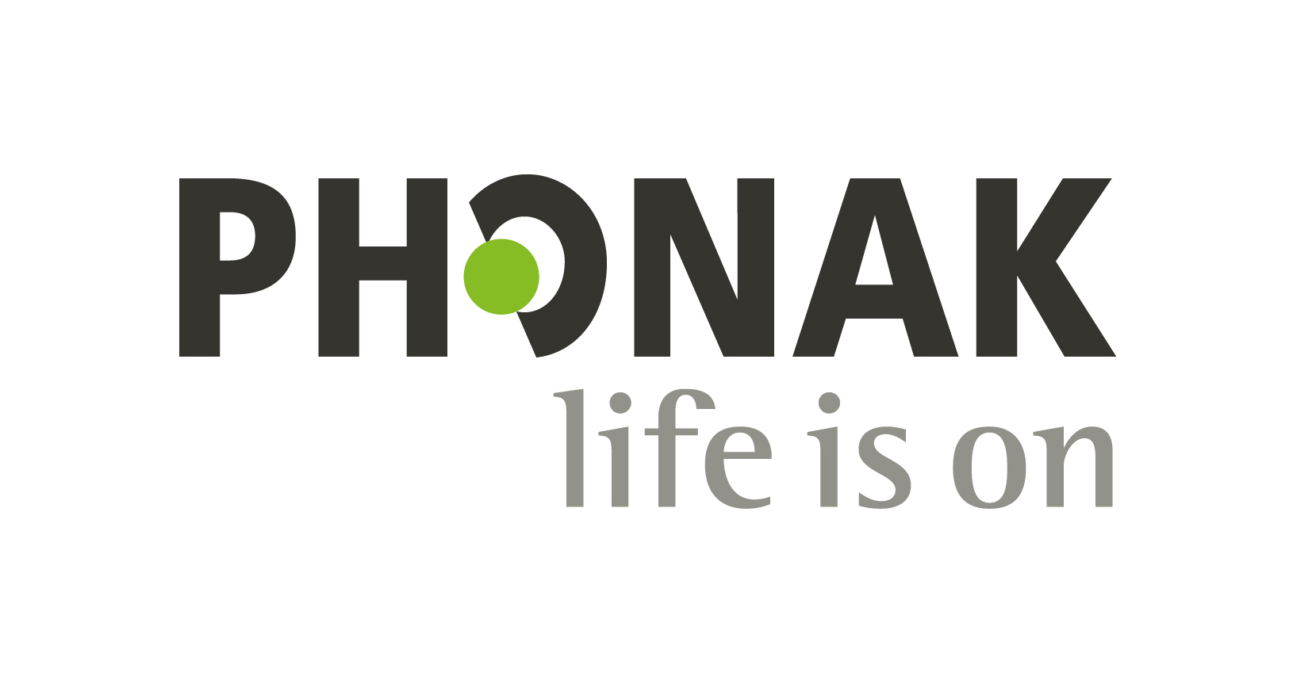City, State, Zip

1 Thibodeau, L. (2014). Comparison of speech recognition with adaptive digital and FM wireless technology by listeners who use hearing aids.American Journal of Audiology, 23(2), 201-210.

2 Winneke, A., Schulte, M. and Latzel, M. (2019). The effect of spatial noise processing in hearing aids on neural correlates of listening and memory effort: an EEG study. Manuscript in preparation. Expected beginning of 2020.

The Bluetooth® word mark and logos are registered trademarks owned by Bluetooth SIG, Inc. and any use of such marks by Sonova AG is under license.

iOS is a trademark of Cisco, Inc.

Android is a trademark of Google LLC.

©2020 Sonova USA Inc. All rights reserved. 277DB. MS-XXXXXX.

Practice Logo

[Practice Name]  
[Street Address]  
[City, State]  
[Website]

**You’re invited to our   
Power Meets Connectivity Hearing Event!**

**For XX days only**

**Month XX–XX, 2020**

During your appointment, you’ll receive:

• **Complimentary** hearing screening

• **Live demo** of Naída Marvel and   
Roger technology

• **30-day** in-home trial evaluation

**Introducing Phonak Naída™ Marvel, the world’s first super power hearing aid with universal Bluetooth® connectivity**

Dear CLIENT NAME,

I’m excited to introduce you to the newest in power hearing technology, Phonak Naída Marvel. Naída Marvel delivers powerful, rich sound and directly connects to billions of Bluetooth-enabled devices including smartphones, TVs, tablets, PCs and more.

Naída Marvel employs a unique suite of dedicated technologies that modify, compress, amplify and ultimately help distinguish sounds, bringing people with a severe to profound hearing loss like yours closer to the beauty of sound.

* Better speech understanding in noise with Roger1
* Reduced listening effort and better memory recall in noise​2
* RogerDirect™ allows Roger microphones to stream directly to Marvel hearing aids ​
* True hands-free phone calls ​
* Directly connects to iOS®, Android™ or other   
  Bluetooth-enabled devices​

Trying them out is simple! Just bring this letter to your appointment. We’ll give you a personalized demonstration and give you the chance to try these **NEW** state-of-the-art hearing aids at home for up to 30 days. This offer is only available for a limited time.

**Join us for our special Power Meets Connectivity Hearing Event, Month XX–XX, 2020.**

**Call today at xxx.xxx.xxxx or visit provideurl.com to book an appointment before they fill up!**

We look forward to hearing from you!

Signature

Audiologist Name

Credentials